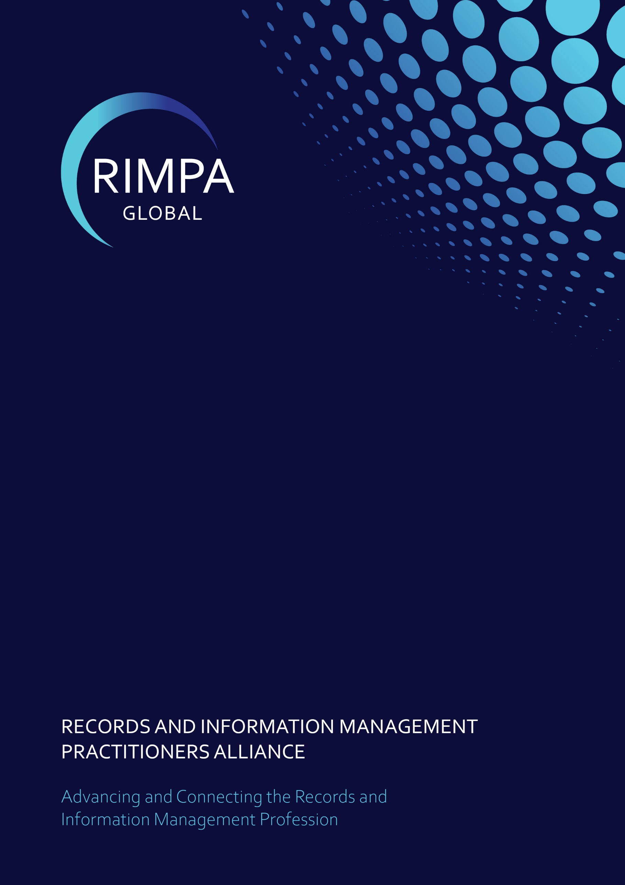
Education Committee
Terms of Reference
31/05/2025

TABLE OF CONTENTS
1 Purpose 2
2 OBJECTIVES of the COMMITTEE 2
3 Term of the working group 2
4 Responsilbe Portfolio 3
5 Authority 3
6 Organisation 3
6.1 Membership 3
6.2 Structure 4
6.3 Appointment and resignations 4
6.4 Meeting protocol 4
6.5 Voting procedures 4
7 Roles and Responsibilities 4
7.1 Portfolio lead 4
7.2 CEO or Business Development Manager 4
7.3 Chair 4
7.4 Secretariat 5
7.5 Working Group members 5

DOCUMENT CONTROL
Version | Date | Author(s) | Approval | Comments
0.1 | 14/05/2025 | Anne Cornish
AMENDMENT, MODIFICATION OR VARIATION
- This Terms of Reference is effective from 31/05/2025 and is to be reviewed every two years.

Purpose
The Education Committee is established to advance the professional standing and visibility of Records and Information Management (R&IM) through education, advocacy, and collaboration. The committee will focus on strengthening education pathways, promoting career opportunities in R&IM, aligning skills development with industry needs, and removing barriers to practical experience for students and early-career professionals.

OBJECTIVES of the COMMITTEE
The committee’s objectives are to:
- Increase the Visibility and Value of R&IM:
  - Address standardised language and messaging across sectors.
  - Recommend marketing campaigns promoting R&IM as a strategic business function.
- Influence Key Stakeholders on the Importance of Higher Education in R&IM:
  - Define and communicate the business value of strong IM practices.
  - Create targeted campaigns for stakeholder groups, including tailored micro-courses and cross-discipline webinars.
  - Establish partnerships with allied associations such as DAMA, ALIA, ASA, and InfoGovANZ to promote IM education.
- Enhance Access to Educational Resources and Practical Experience:
  - Develop a centralised student resource portal in collaboration with SAI Global and other standards organisations.
  - Establish a host organisation register for student placements and practicums.
  - Create standardised practicum guidelines to ensure meaningful placement experiences.
  - Promote the benefits of hosting students to businesses and government agencies.
- Ensure RIMPA Offers Relevant and Evolving Educational Opportunities:
  - Assess member needs and emerging industry trends to inform the development of new educational offerings.
  - Regularly review the relevance and quality of RIMPA’s existing training programs, certifications, and learning pathways.
  - Identify opportunities to partner with reputable training vendors, technology providers, and subject matter experts to deliver high-value education and professional development.
  - Ensure all offerings cater to varying experience levels—from entry-level to expert.

Term of the working group
The Education Committee will operate on a rolling two-year term, with a formal review of its Terms of Reference and performance every two years.

Responsilbe Portfolio
Industry Education

Authority
The CEO authorises the Education Committee
- Undertake activities that support its objectives.
- Seek information from RIMPA Global employees, members, and partner organisations.
- Endorse and recommend solutions, but final decision-making remains with the RIMPA Board.

Organisation

Membership
- Chair (elected by committee members)
- Secretariat (RIMPA Global staff member)
- At least 3 and no more than 8 committee members, including:
- Education Port Folio Lead (Mandatory)
- RIMPA Global Ambassador (Mandatory)
- RIMPA Global Staff or CEO (Mandatory)
- Industry Representatives
- Education Sector Representatives
- Partner Organisation Representatives

Committee members should have:
- An understanding and passion for R&IM education and training
- Networks or relationships with tertiary and secondary education providers,
- a commitment to providing excellent and informative outputs
- good communication skills
- a demonstrated high level of emotional quotient
- the ability to understand the perspectives and experiences of others

Structure

Appointment and resignations
- Committee members may be appointed at any time through a majority vote of the committee.
- Committee members may resign by notice to the Chair at any time.
- Where a member resigns and they have recognised responsibilities, the Chair will reassign to another member.

Meeting protocol
- Meetings are to be held as required.
- The Chair may invite guests as they deem necessary to attend and advise at meetings.
- A quorum for any meeting will be the Chair or proxy and any one member.

Voting procedures
- A motion raised during a meeting is considered successful when it is supported by a majority of members present at the meeting.
- Where a motion is not supported by majority vote, it is considered unsuccessful.
- In the case of equality votes, the chair has the casting vote.

Roles and Responsibilities

Portfolio lead
Is responsible for:
- Overseeing committee governance.

CEO or Business Development Manager
Is responsible for:
- managing budget requirements where applicable
- providing the escalation point for all matters.

Chair
Is responsible for:
- scheduling committee meetings
- setting the agenda
- reporting to the CEO and Board on approved motions

Secretariat
Is responsible for:
- scheduling committee meetings as advised by the Chair
- taking note of actions and tasks
- following up on outstanding actions or tasks
- updating the CEO on progress

Working Group members
Are responsible for:
- Collaborate to achieve objectives.
- Engage with industry and education partners to advance committee initiatives.
- Develop and document outcomes, including research and educational materials.
- Attend meetings and contribute to discussions in a timely and respectful manner.

