# Exhibitor Portal APP Instructions

1. Go to exhibitor portal Link: <https://events.rdmobile.com/Account/Login>
2. If the below screen does not appear immediately for your leads to be downloaded, follow steps 3 – 7 below.

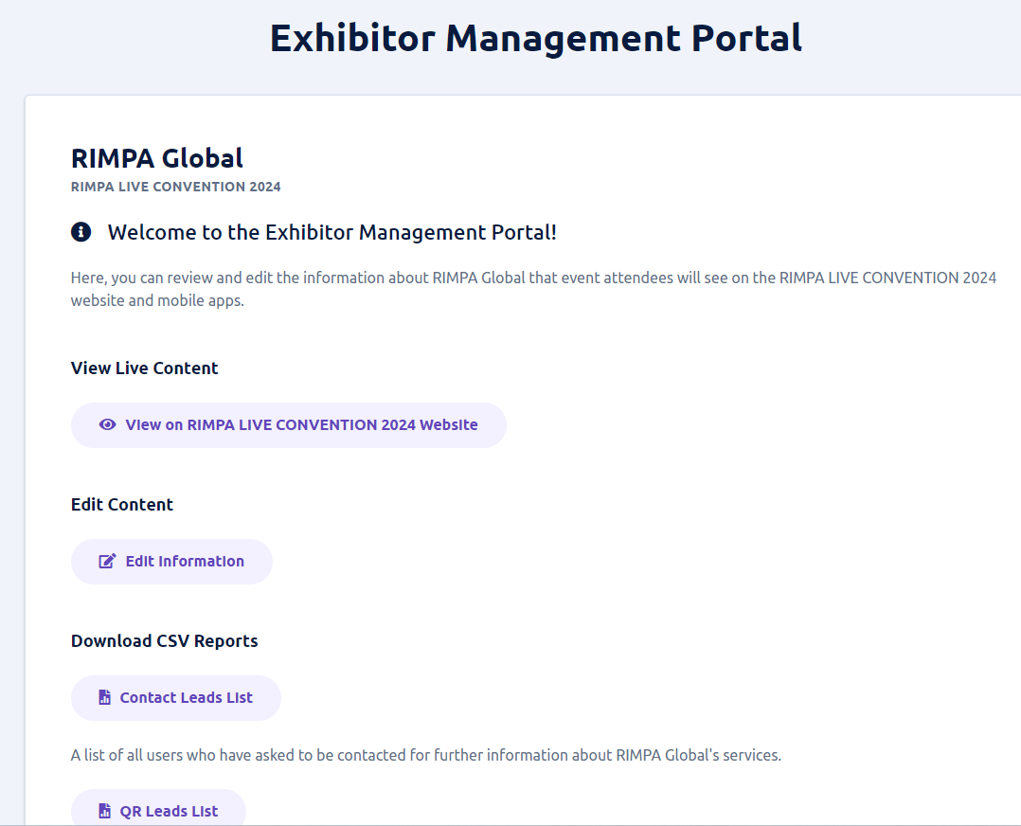

1. Choose your organisation under ‘My Organisations’ then choose “All Events”

1. Choose RIMPA Live Convention 2024

1. Choose Find Solutions and find your organisation in the Featured Exhibitors section. Choose Your Organisation.
2. Once your organisation is chosen choose Edit

1. The Exhibitor Management Portal will then appear (Step 2 of these instructions above)

1. From this screen your exhibitor information can be edited, Contacts Leads List can be exported or your QR Leads List.