AI & Information Management Community of Practice

Launch Poll Results — 20 May 2026
Five poll questions were put to attendees at the CoP launch session. This document summarises the responses, including counts and percentages for each multiple-choice option, and the key themes from the open-text question.

1. What would you most like this Community of Practice to help you with?
13 respondents, multiple selections allowed.
Response | Votes | %
Applying governance and recordkeeping principles to AI | 11 | 85%
Shared tools, checklists, or guidance | 9 | 69%
Confidence in advising or challenging AI initiatives | 8 | 62%
Networking and peer learning | 6 | 46%
Practical use cases and case studies | 5 | 38%
Understanding AI fundamentals (terminology, concepts) | 3 | 23%
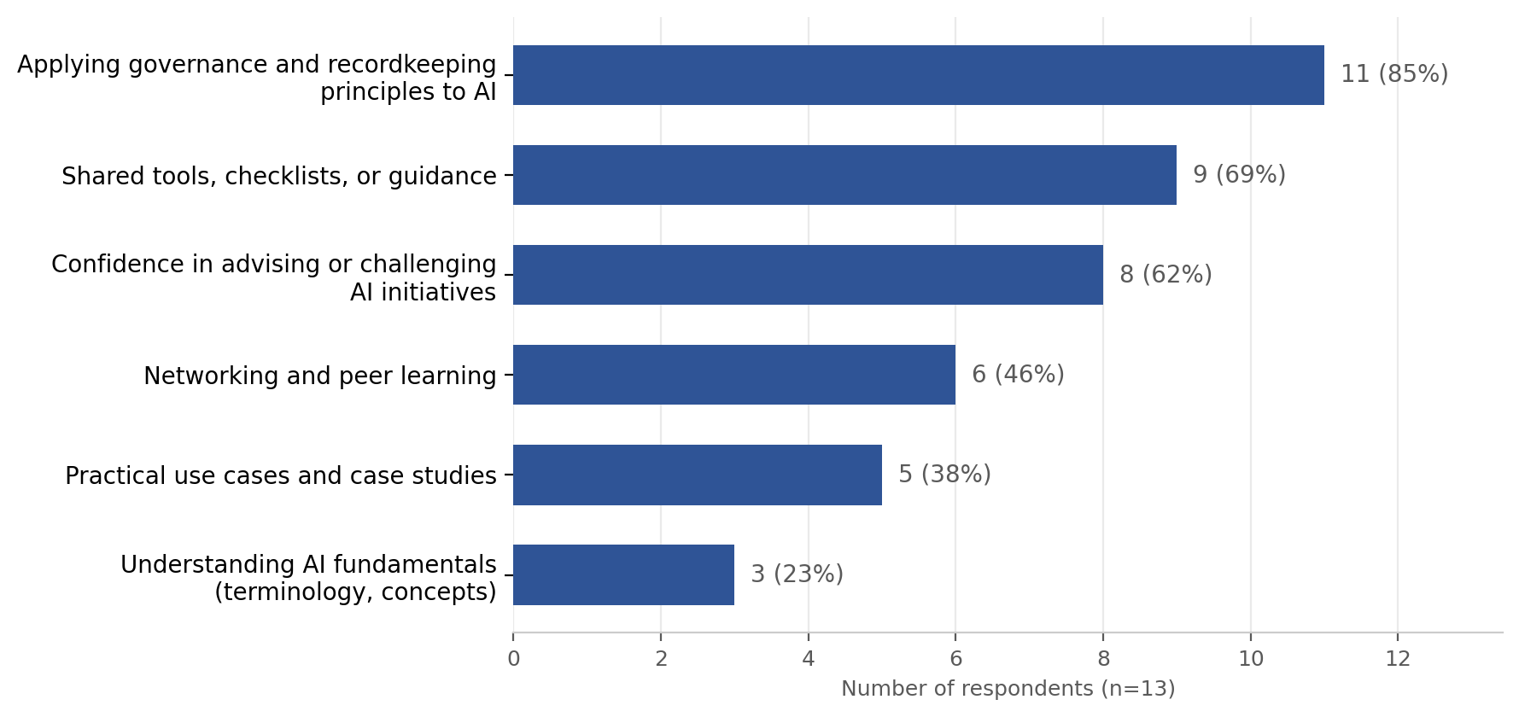
Takeaway: Governance/recordkeeping application is by far the top priority, followed by practical tools and confidence-building. Basic AI literacy is a lower priority — most respondents feel past that stage.

2. What session formats would be most engaging?
15 respondents, multiple selections allowed.
Response | Votes | %
Short expert inputs followed by discussion | 9 | 60%
Practitioner case studies | 9 | 60%
Guided group discussion | 9 | 60%
Open Q&A / “bring your problem” sessions | 8 | 53%
Scenario based problem solving | 5 | 33%
Panel sessions | 2 | 13%
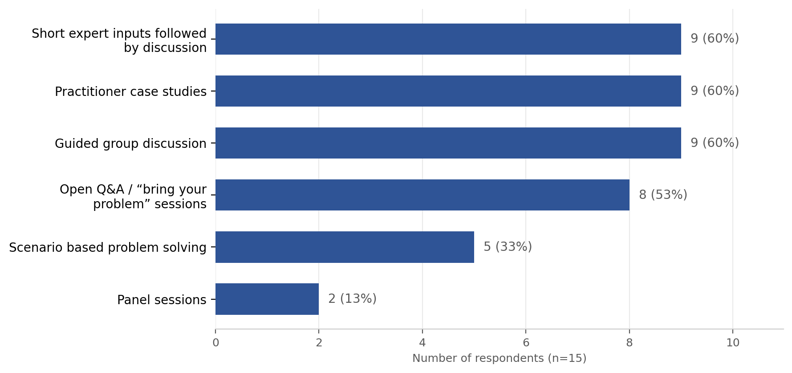
Takeaway: A three-way tie for top format suggests a mixed-format session structure (short input → case study → discussion) would suit the group best. Panels are clearly the least popular format.

3. Which topics should the CoP explore over the next few sessions?
15 respondents, multiple selections allowed.
Response | Votes | %
Governance models for AI use | 12 | 80%
Record creation, capture and retention in AI-enabled systems | 9 | 60%
Mapping AI practices to standards and legislation | 9 | 60%
Accountability, auditability and explainability | 5 | 33%
Procurement and vendor claims | 4 | 27%
Managing risk and assurance | 4 | 27%
Developing organisational guidance | 3 | 20%
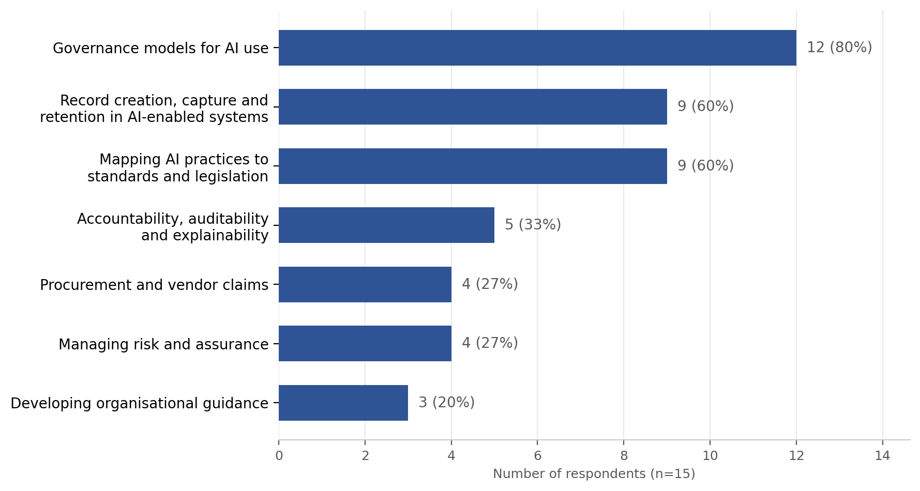
Takeaway: Consistent with Question 1 — governance is the clear number one topic, with recordkeeping-specific practice and standards/legislation mapping close behind.

4. What would help you feel comfortable contributing to discussions?
15 respondents, multiple selections allowed.
Response | Votes | %
Already comfortable contributing | 12 | 80%
Clear framing questions | 7 | 47%
Being able to contribute via chat | 7 | 47%
Knowing views won’t be attributed | 5 | 33%
Smaller group or breakout discussions | 3 | 20%
Hearing examples before being asked to comment | 3 | 20%
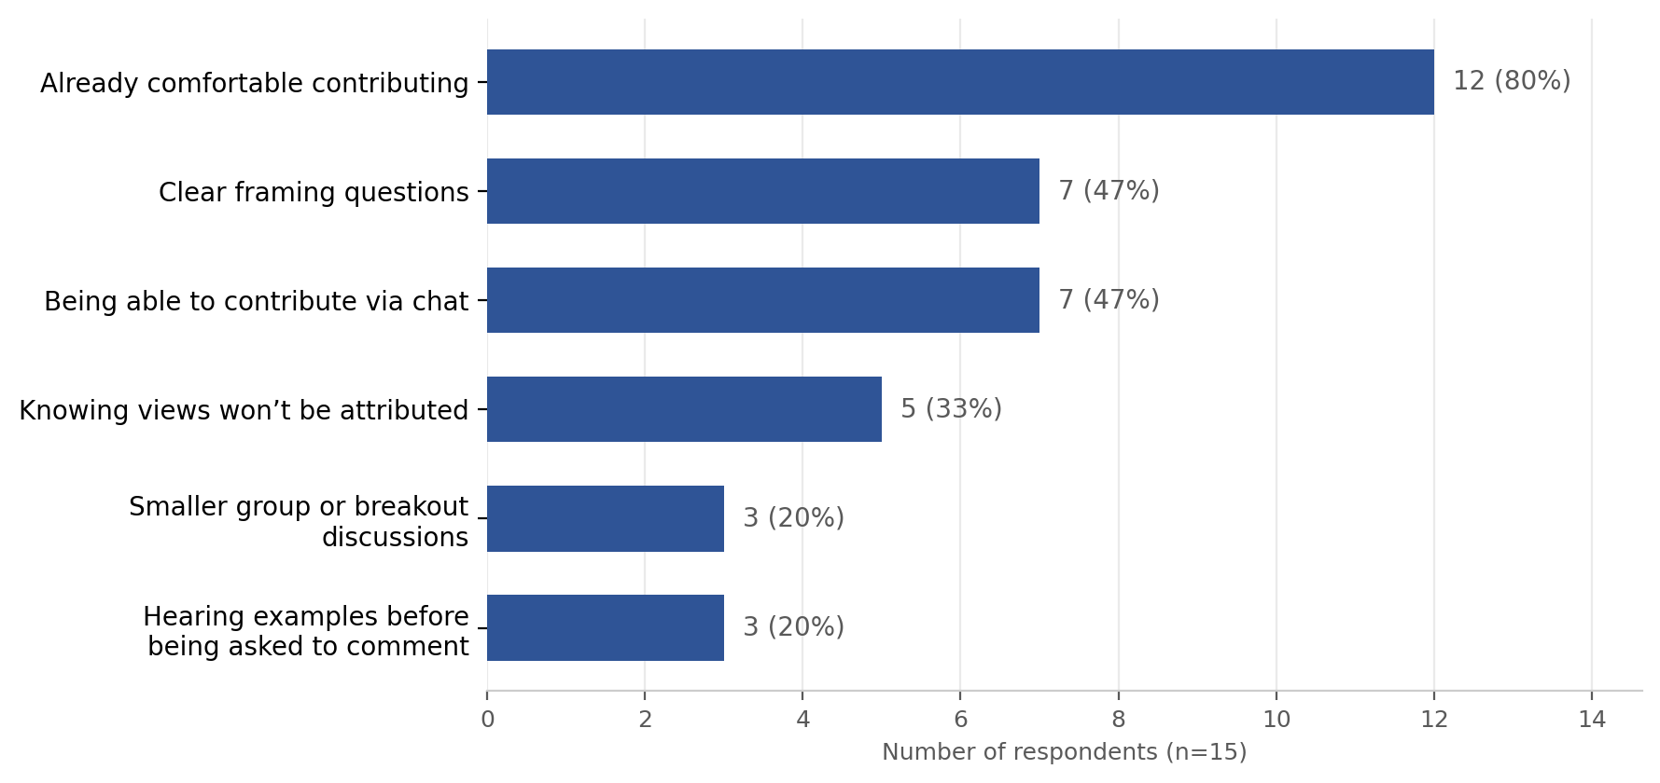
Takeaway: Most feel comfortable already, but a meaningful minority would engage more with anonymity/non-attribution, chat options, and clearer framing — worth building in as light-touch facilitation options rather than defaults.

5. Is there one thing you definitely don’t want this CoP to become?
13 respondents, open text. Responses clustered around three themes:

Lack of direction or purpose
- “Aimless” (x2)
- “A group without a clear purpose and plan”
- “Irrelevant”
- “Roadmap”
- “A goat rodeo”

Repetitive talk without action
- “Chat fest on the same topics over and over”
- “Whinge-fest”
- “No complaining, more how do we do it”
- “Educational”

Bias or agenda-driven
- “An endorsement of AI”
- “Sales pitch”
- “Compliance heavy”
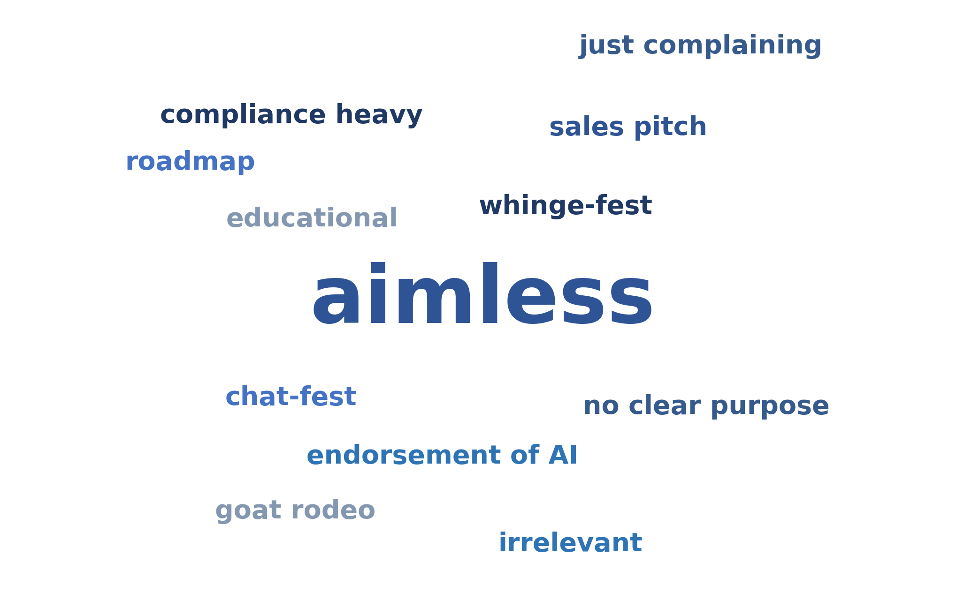
Takeaway: Participants want a purposeful, balanced, action-oriented group — not a repetitive gripe session, a compliance lecture, or an AI cheerleading squad.

Overall synthesis
There is strong alignment across all four multiple-choice questions: governance and recordkeeping application is the clear top priority, both for support needed and topics to cover. The group wants varied, interactive session formats rather than lecture- or panel-heavy sessions, and while most are comfortable speaking up, offering chat-based and anonymous input options would broaden participation. The open-text answers reinforce that the CoP needs a clear purpose and practical focus to avoid becoming repetitive, compliance-heavy, or agenda-driven.

