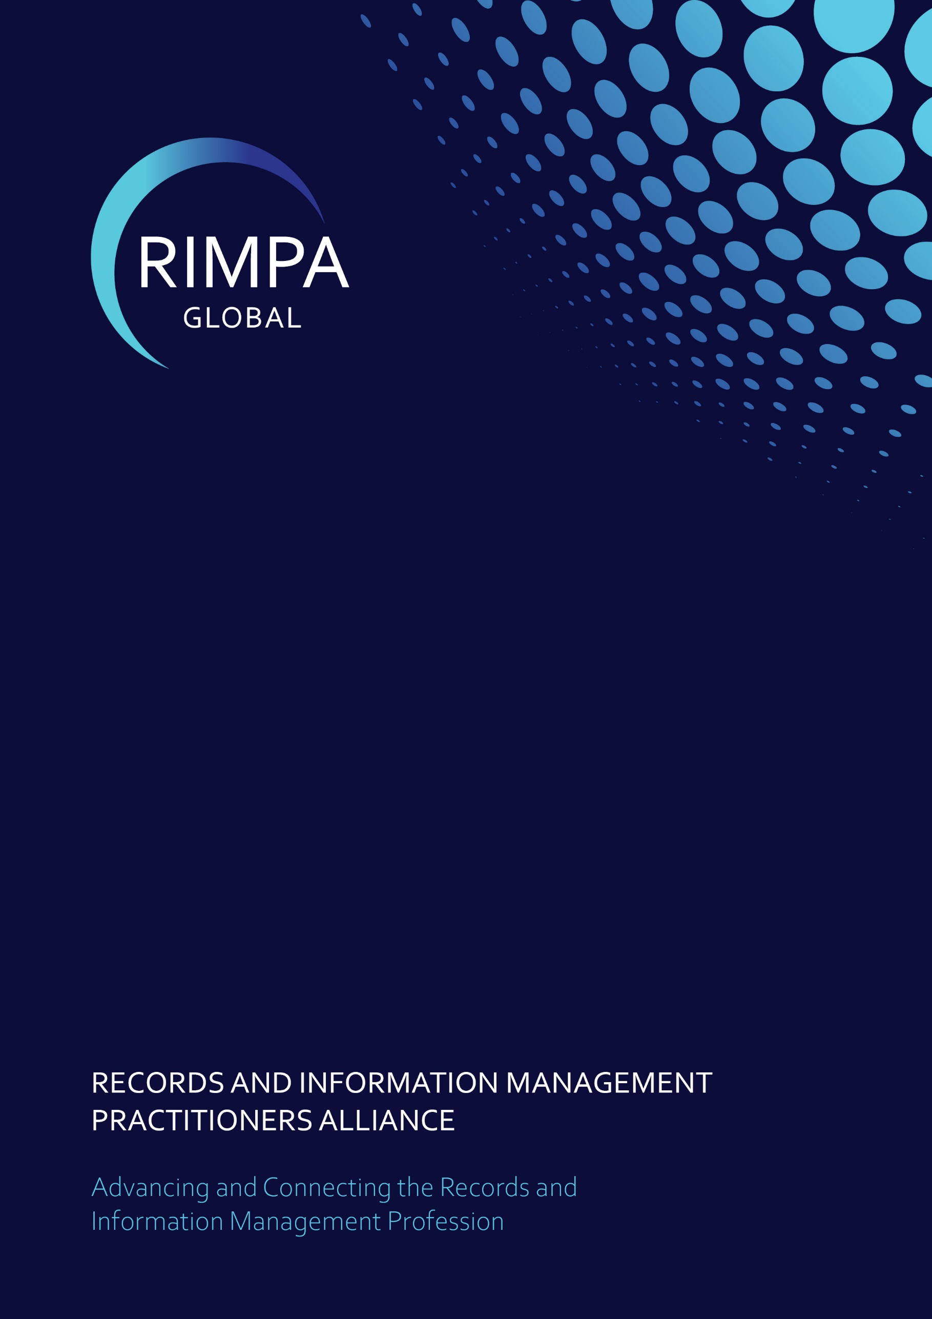
Hall of Fame

13 January 2025

Table of Contents
1. Introduction 2
2. Award Timing 2
3. Eligibility 2
4. Advisory Panel 2
5. Judging Panel 3
6. Award 3
7. Nomination Requirements 3
8. Nomination Categories 3
8.1. RIMPA Global Involvement 4
8.2. Industry Involvement 4
8.3. Personal Characteristics 5

DOCUMENT CONTROL
Version | Date | Author(s) | Approval | Comments
1.0 | 30/06/2020 | Nancy Taia | RIMPA Global Board | Creation of criteria
1.1 | 04/08/2023 | Nancy Taia | Anne Cornish | Addition to RIMPA Global involvement to include Board appointed representatives
2.0 | 19/02/2024 | Awards Committee | Anne Cornish | Bi-annual review
2.1 | 10/01/2025 | Nancy Taia & Anne Cornish |  | Criteria review due to 2024 process feedback
2.2 | 13/02/2025 | OWLS |  | Feedback on updates
3.0 | 26/02/2025 |  | Anne Cornish | Approved

AMENDMENT, MODIFICATION OR VARIATION
- This criteria is effective from 1 July 2020 and is reviewed every two years.
- This criteria may be amended, varied, or modified by the RIMPA Global Board.

Introduction
Founded in 2019, the RIMPA Global Hall of Fame honours remarkable contributors in the records and information management industry.
As the digital age continues to transform how information is captured, stored, and accessed, the importance of thorough records and information management has never been greater. The individuals celebrated in this Hall of Fame have played a crucial role in setting industry standards, driving innovation, and ensuring the integrity and accessibility of information.
Through their leadership, expertise, and commitment, they have strengthened recordkeeping frameworks, influenced policy and best practices, and fostered a culture of excellence in managing information assets. This Hall of Fame serves as both an acknowledgment of their achievements and an inspiration for future generations of records and information professionals.

Award Timing
Nominations must be submitted to the RIMPA Global Board by 30 June and new inductees are announced at the awards dinner held during RIMPA Live.

Eligibility
Nominees are presented to the RIMPA Global Board with the inductees chosen due to their long-standing commitment and dedication to RIMPA Global and/or how they have influenced the direction of the records and information management industry. Their contributions will have impacted and inspired their peers and younger members, encouraging them to achieve their potential.
The following details the eligibility criteria:
- Any member of RIMPA Global may be eligible for induction into the Hall of Fame irrespective of their employer (they can be vendors).
- Sitting members of the RIMPA Global Board cannot be nominated or inducted into the Hall of Fame.
- A member of the advisory panel may be a nominee but shall not provide feedback on their induction into the Hall of Fame.
- There shall be a maximum of three inductees to the Hall of Fame each year. There is no minimum requirement.
- Nominations for induction into the Hall of Fame cannot be self-submitted.

Advisory Panel
- The Board may seek further advice on nominations from other sources to understand the nomination received. These sources may be, but not limited to:
  - To provide further information to nominations received, the Our Wise Leaders (OWLS) group may be approached for their insight on nominees. As a distinguished group of records and information practitioners who have played an integral role in shaping the history and progress of RIMPA Global since its establishment in 1969, the OWLS have profound insights into the evolution and transformation of the industry over the past 50+ years, these esteemed OWLS bring invaluable knowledge and experience to the table.
  - The RIMPA Global CEO will also act in an advisory role, utilising the records of the Company to provide any additional information required to support or oppose the nomination.

Judging Panel
- RIMPA Global Board of Directors will vote on the nominations submitted to induct a nominee into the Hall of Fame.
- For a nominee to be inducted they must receive endorsement from a minimum of 80% of the judging panel.

Award
- The Hall of Fame inductee/s will have their name added to the perpetual trophy and receive an individual trophy.

Nomination Requirements
- Nominations must be submitted by a nominator; they cannot be self-submitted.
- Nominees must be a current RIMPA Global member or a past member who has retired.
- Nominations must be submitted responding to one or both categories:
  - RIMPA Global Involvement
  - Industry Involvement.
- Nominations must address the Personal Characteristics category.
- Nominations must include:
  - one letter of recommendation (no more than 500 words)
  - evidence and testimonials where appropriate.
- Nominator to send the nomination, with supporting evidence, to awards@rimpa.com.au.

Nomination Categories
- The judging panel will evaluate the nominations against the relevant category, as well as the Personal Characteristics category.

RIMPA Global Involvement
- The nominee must have had a long-standing involvement with RIMPA Global, more than 15 years, or had a major impact on the development of the Company.
- The nominee must have held professional membership.
- The nominee must have participated in the delivery of services to the RIMPA Global membership.
- They must have contributed to the fulfillment of the RIMPA Global strategic objectives, this can include, but is not limited to:
  - serving or served as a director on the RIMPA Global Board
  - serving or served as a portfolio lead
  - serving or served as a Board appointed representative
  - serving or served as an ambassador
  - serving or served as an active member on a Committee or Working Group
  - served as a Branch or Chapter executive
  - demonstrated contribution to RIMPA Global strategic plan
  - delivery of training, presentations, or webinars at RIMPA Global events (at any level)
  - writing of published articles in the iQ or RIMPA Global Newsletters
  - contributor on the RIMPA Global community forum.

Industry Involvement
- The nominee must be successful in the records and information management industry as determined by the judging panel which is demonstrated through:
  - significant contribution to the broader records and information management industry
  - positive influence on others within the industry
  - participation and contribution in other records and information management industry groups, this can include, but is not limited to:
    - Standards Committees
    - Global Community of Practices
    - Global Information Consortium

Personal Characteristics
- The nomination must demonstrate how the nominee portrays the RIMPA Global values:
  - Empowerment (e.g. mentoring, delivering training, demonstrated leadership, knowledge sharing)
  - Nurturing (e.g. volunteer work, social contributions, personal professional development)
  - Collaboration (e.g. presentations, networking groups, social media)
  - Innovation (e.g. new ideas, Hackathons)
  - Ethical Practice (e.g. personal attributes recognised by society as acceptable, appropriate, and worthy enough to be acknowledged as a role model)

