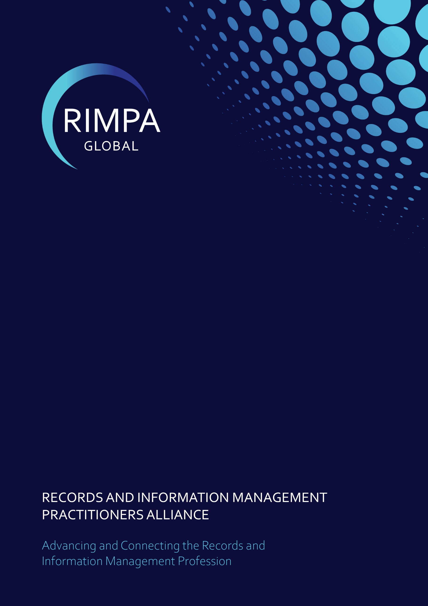
RIMPA Research Advisory Committee (RIMPA RAC)
Terms of Reference (ToR)

TABLE OF CONTENTS
DOCUMENT CONTROL 1
AMENDMENT, MODIFICATION OR VARIATION 1
1 PURPOSE 2
2 TERM OF RIMPA Research ADVISORY committee 2
3 ADVISORY COMMITTEE OBJECTIVES 2
4 AUTHORITY 3
5 ORGANISATION 3
5.1 Membership 3
5.2 Appointment and Resignations 4
5.3 Meeting Protocol 4
5.4 Voting Procedures 4
6 ROLES AND RESPONSIBILITIES 4
6.1 CEO 4
6.2 Board Member 4
6.3 RIMPA Research Advisory Committee Chair 5
6.4 RIMPA Global Team 5
6.5 RIMPA Research Advisory Committee Members 5

DOCUMENT CONTROL
Version | Date | Author(s) | Approval | Comments
01 | 23 June 2025 | 2024 RIMPA Hackathon team |  | Document prepared by 2024 Hackathon team: Alicia Slamkovic, Debra Menzies, John Cox, Louise Curham, Machelle Tennent
0.1 | 26 June 2025 | CEO |  | Feedback from Board members and OWL Group

AMENDMENT, MODIFICATION OR VARIATION
- This TOR is effective from 1 July 2025 and is reviewed every two years
- This TOR may be amended, varied, or modified by the Records and Information Management Practitioners Alliance Global (RIMPA Global) Board

PURPOSE
The purpose of this document is to outline the Terms of Reference under which the RIMPA Research Advisory Committee (RIMPA RAC) will operate, providing a clear framework for its functions, responsibilities, and authority.

TERM OF RIMPA Research ADVISORY committee
Members may serve a maximum of two (2) consecutive terms, each lasting three (3) years. Following this period, members must step down for a minimum of three (3) years before being eligible for reappointment to the RIMPA RAC.

ADVISORY COMMITTEE OBJECTIVES

The RIMPA Research Advisory Committee (RIMPA RAC) is responsible for advising the RIMPA Board on research-related matters, including the development and evaluation of funding frameworks, and identifying key research priorities and opportunities within the sector. Specifically, the Committee will:

• Research Grant Allocation: establishing assessment criteria, providing guidance on applicant eligibility, and evaluating applications to recommend successful recipients.

• Research Priorities and Gaps: identifying and evaluating significant areas of research activity within the sector, determining research priorities that align with national and international needs, and identifying gaps that require further exploration.

• Sector Trends and Opportunities: Advise on emerging research trends, issues, and opportunities relevant to the records and information management sector globally.

• Research Policy and Infrastructure: Respond to policy consultations and changes in research infrastructure, funding models, or sector-related frameworks that may impact RIMPA’s research efforts.

• Collaborative Research: Recommend opportunities for interdisciplinary and cross-sector collaboration, including partnerships with academic institutions, government, and industry, to enhance research outcomes and sector impact.

• Research Translation and Impact: Provide input on how RIMPA communicates and applies research findings, ensuring knowledge translation delivers practical value to practitioners, policymakers, and other stakeholders.

In addition, the Committee may be asked to advise on:

• Specific research topics and reports
• Research proposals and activities for RIMPA
• RIMPA’s responses to consultations

AUTHORITY
The Board authorises the RIMPA Research Advisory Committee to make recommendations and take actions as set out in 3 Objectives.

ORGANISATION

Membership

The RIMPA Research Fund may comprise of up to eleven (11) members by invitation from the CEO as advised by the RIMPA RAC. The minimum number of members is six (6).

RIMPA RAC will elect one member as Chair or two (2) members as Co-Chairs. The maximum term for a Chair is six (6) years.

To achieve its objectives, the Committee is comprised of a mix of diverse skills, expertise, and backgrounds.
Core Members (6)
- Academic Representative – a university academic with sector expertise.
- RIMPA Board Member
- RIMPA CEO
- Technology Specialist – an expert in emerging technologies such as AI, blockchain, or digital preservation relevant to IM research.
- Legal & Ethics Advisor – member who brings expertise in data privacy, records compliance, and ethical considerations in IM research.
- Funding/Finance Officer – member with finance experience to assist with budget oversight, grant allocations, and financial governance.

Non-Core Members
- End-User Representative – a practitioner who regularly deals with IM challenges and can provide practical insights.
- Government Representative – a senior officer from a government agency with information policy responsibility (e.g., CAARA member).
- International Representative –a representative from an international IM body.
- Community or Public Engagement Specialist – If the fund supports public-facing research, representative with expertise in citizen engagement and public policy.
- Student – RIMPA Student member
- Industry expert – a representative with IM expertise from industry relevant to IM research

Appointment and Resignations
- Members may be invited to join the Committee by the CEO as advised by the RIMPA RAC at any time upon resignation of a member or by request from the Committee
- Members may resign by notice to the CEO or Committee Chair at any time.
- Where a member resigns and they have recognised responsibilities, the Chair will reassign such responsibilities to another member.

Meeting Protocol
- Meetings are to be held online and will be convened by the RIMPA Global Team under direction from the Chair of the RIMPA RAC.

- Individuals or organisations may be invited to participate in discussions where they have specific knowledge, expertise, or experience

- The agenda and supporting documentation will be distributed to Committee members at least three (3) working days prior to each meeting

- A quorum for any meeting will be any four (4) members

Voting Procedures
A proposal raised during a meeting is considered successful when it is supported by majority of members present at the meeting. Where a motion is not supported by majority vote, it is considered unsuccessful.
A motion raised by flying minute (electronic or digital vote) is considered successful when it is supported by majority of all Committee members. Where a motion is not supported by majority vote, it is considered unsuccessful.

Recommendations presented to the Board are to be those agreed to by the majority and are to be made to the board in writing or verbally at an assigned meeting.

ROLES AND RESPONSIBILITIES

CEO
- Governance and financial advice
- Providing the escalation point for all matters

Board Member
- Liaison between the Board and RAC
- Provide RAC guidance on RIMPA’ s strategic direction

RIMPA Research Advisory Committee Chair
- Setting meeting dates and times
- Setting the agenda
- Managing meeting discussions

RIMPA Global Team
- Scheduling meetings as advised by Chair
- Taking notes of meetings
- Disseminating actions to all Committee members

RIMPA Research Advisory Committee Members
- Co-developing activities to support the agreed strategies and goals
- Attending Committee meetings
- Enjoy the experience and camaraderie.

